**抑郁问卷的异质性：基于对27个抑郁测量问卷的内容分析**

汪浩远1, 胡孟真1, 田柳青1, 刘伟彪1, 安媛媛1, 李瑛2, 胡传鹏1#

(1南京师范大学心理学院; 2首都医科大学附属北京儿童医院精神科)

**Assessing the heterogeneity of 27 scales for measuring depression**

Haoyuan Wang, Mengzhen Hu, XXX

**CrediT Author Statement**

**Wang Hao Yuan：**Conceptualization, Data curation, Investigation, Writing - Original Draft. **Hu Meng Zhen：**Data curation, Visualization, Investigation. **Tian Liu Qing:** Investigation. **Liu Wei Biao:** Investigation. **Yuanyuan An:** Writing- Reviewing and Editing. **Ying Li:** Writing- Reviewing and Editing. **Hu Chuan-Peng：**Supervision**,** Project administration, Writing- Reviewing and Editing.

Corresponding author: Hu Chuan-Peng, email: hcp4715@hotmail.com

摘要

关键词

# 1. 引言

按照总分总方式写主旨句

[第一段的主旨句]

抑郁障碍的严重性（患病率、社会成本等），青少年期和成年早期是关键的时间。

[第二段的主旨句]

自评量表在抑郁症的研究中广泛使用，也是各类关于青少年与学生政策的基础（中国、世界范围内大规范调查的的数据）

[第三段的主旨句]

但抑郁自评量表数量繁多，被广泛使用的量表也不在少数，有潜在的重大影响（如影响到心理健康问题的检出率）。

[第四段的主旨句]

当前研究发现不同抑郁问题可能在测量不同的内容。Fried（2017年）的研究表明，不同的抑郁量表不能互相替代使用，这给抑郁研究带来了挑战。

[第五段的主旨句]

上述问题可能也延伸到发展中国家，但目前没有实证的数据进行评估，本研究将对用于学生的抑郁自评量表进行分析。

还可以补充一些非常广泛的调查，只用了某一个问卷。可以用大规模调查用的问卷来举例。例如中国国民心理健康发展报告，心理所的调查只用了ces-d简版和中国心理健康量表简版广泛焦虑。

# 2. Methods

We took three steps to extract symptoms from all scales that measure depressions among students population. Firstly, we identified all scales that has been used for screening depression among students and screen the scales for completedness of their items information. Secondly, we identified symptoms of each scale by combining different items that measures the same symptom. Thirdly, we compared the symptoms between different scales. The latter two steps were first proposed by Fried (2017) but slighted modified here (see details) below. The flowchart of our data extraction and content analysis can be found in fig 1.

## 2.1 Identify and screen scales

We identified scales that measure depression from four recent meta-analyses which synthesized the prevalence of different mental health problems among four students populations: elementary school, middle school, high school, and college (于晓琪等, 2022; 黄潇潇等, 2022; 张亚利等, 2022; 陈雨濛等, 2022). We focused on the scales used for screening depression and identified 34 scales from these four meta-analysis.

We carefully selected the version of each scales to ensure the authenticity of the items of each scale included in our final analysis. We first retrieved all 470 articles that included in the above-mentioned four meta-analyses and that were used for screening depression. Then, we compared different versions of the scales with the same name. The main reason for scales share same names is that they were translated by different translators from roginal scales in English or other languages. We employed the following criteria for choose the best version when there are multiple versions: (1), whether or not the version of the scale have been revised, if yes, we usually use the revised version; (2), whether the version of the scale has been validated in at least one Chinese students sample and psychometric indices were reported in the valiation studies; (3), whether symptom names are available for the version of the scale; (4) number of empirical studies, among all 470 papers, that used that specific version. For instance, the 20th item of CES-D, "I could not get going", was translated as “我走路很慢” ("I walk very slowly" as directly back translated into English) by 汪向东等(1999) but was revised by 章婕等(2010), we included the version by 章婕等(2010), where the translation is “我提不起劲儿来做事” ("I lack the motivation to do things" as directly back translated into English).

## 2.2 Merge the items

In this step, we merged items that assess the identical or similar symptom as a single item within each scale. Four trained coders independently merged items for each scale. Four coders were then grouped into two pairs and discussed their results and resolve discrepancies. Subsequently, the two groups and the corresponding author together resolved the discrepancies (if there were any) and created a unified version, which was then verified by a clinically certificated doctor (co-author ***) and revised accordingly.

## 2.3 Compare symptoms across different scales

In this step, we conducted symptoms comparison to determine the overlapping symptoms across all scales, as in Fried (2017). The process was also finished by the following procedure: individual comparision, separate discussion by pairs, group disccusion with all coders and corresponding author, and verification by the author with clinically certificated doctor.

As in Fried (2017), we retained both compound symptoms and specific symptoms, as in Fried (2017). Compound symptoms include a range of related symptoms, whereas specific symptoms are more concrete and describe specific patterns. For example, 'appetite changes' is a compound symptom, whereas 'appetite increased' and 'appetite decreased' are two specific symptoms of 'appetite changes'.

When comparing between scales, it is possible that one scale has an item that measures a compound symptom directly but another scale has items that measure one or more specific symptoms of that compound symptom. Compound and specific symptoms would be considered to overlap. Because of this distinction, we coded the symptoms as following: For symptoms that could be directly measured, the code was 2; for symptoms that were not directly measured, but were specific symptoms under the compound symptom, the code was 1. For instance, we coded the 18th item of CDI, 'appetite changes' as 2 on the symptom 'appetite changes', while specific symptoms of this compound symptom, 'appetite increased' or 'appetite decreased', was coded as 1 because these two are not measured in CDI (see Supplementary Materials and Figure 2 for details).

We employed an approach that maximize the amount of different symptoms. More specifically, if the items describe similar symptom using different words and that the words have significantly different meanings under the Chinese context, we treat them as belonging to the same compound symptom but are different specific symptoms. For instance, there are many different words for describe depressed mood in different scales, we used 'depressed moods' as the compound symptom but distinguish different specific symptoms such as: 'blue', 'low mood', 'sad', and 'anhedonia'. This approach is slightly different from Fried (2017), where he coded all these item as a specific symptom 'Sad moods'.

We reported the following comparative information: descriptive details of different symptoms and the performance and characteristics of scales on various symptoms. Additionally, we provided the proportions of idiosyncratic symptoms (symptoms not found on other scales), the respective proportions of compound and specific symptoms, and the proportions of DSM-5 depressive symptoms included.

## 2.4 Scale overlap

We used Jaccard index for the degree of overlap between different scales (Fried, 2017). The formal of Jaccard index or Jaccard is s/(u1 + u2 + s), where "s" represents the number of items shared by two scales, and "u1" and "u2" denote the number of items that are exclusively present in each of the two scales. Jaccard index ranges from 0 (no overlap among scales) to 1 (complete overlap). We interpreted Jaccard index as in Fried (2017) guidelines: very weak 0.00–0.19, weak 0.20–0.39, moderate 0.40–0.59, strong 0.60–0.79, and very strong 0.80–1.0.

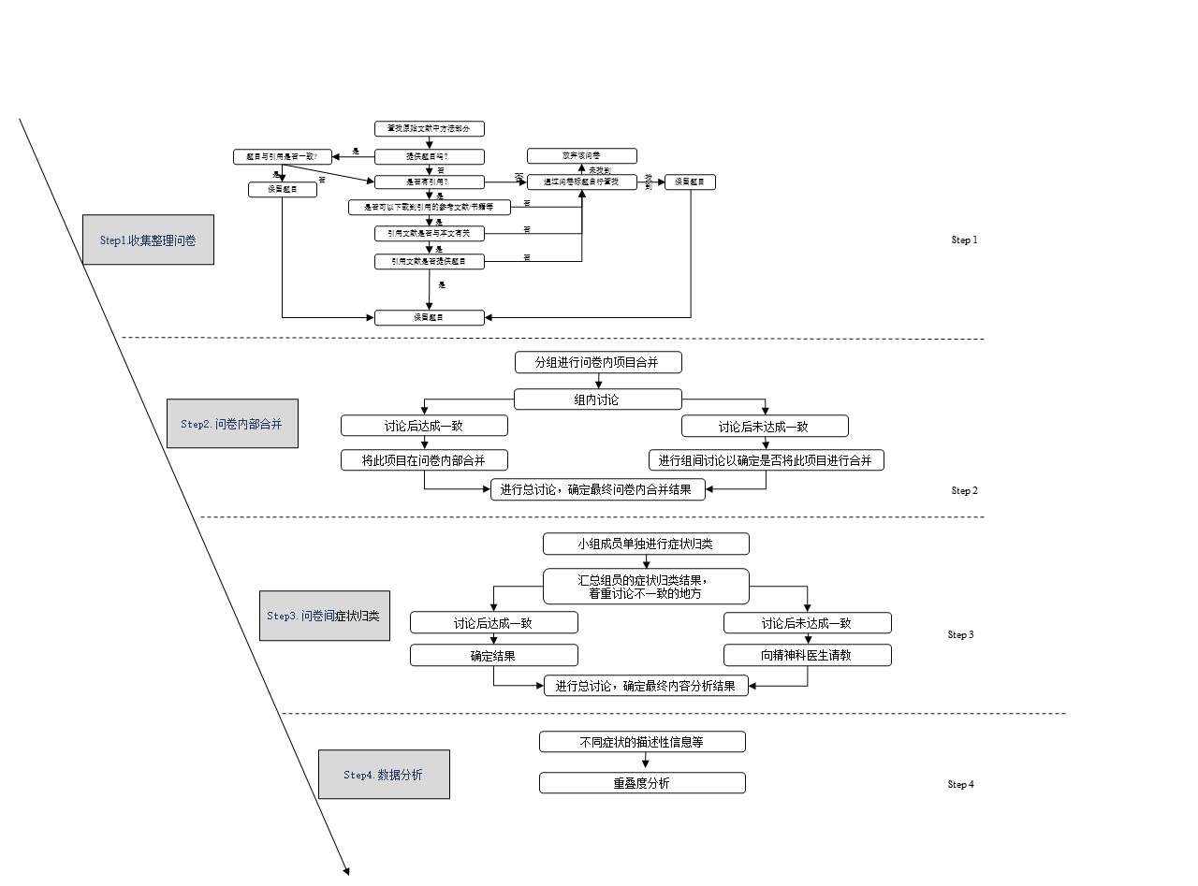

# 3 Result

# 3.1 Description of scales selection

Among these 34 scales, the items of four scales, the Mini International Neuropsychiatric Interview for children and adolescents (Mini-KID), WHO-CIDI 3.0, Psychological Health Inventory (PHI), and the Symptom Checklist 45, were not findable. The citation of two scales, the Beck Depression Inventory (Zhang Yuxin Revised Edition) and Short Depression Scale, could not be identified and thus the items of them can not be identified. As a result, these six scales were excluded from furthere analysis. Both 'Gu & Chen (2020) 'and 'Ji (2007)' measured depression using a single item, ''During the past 12 months, did you ever feel so sad or hopeless almost every day for two weeks or more in a row that you stopped doing your usual activities? ''. The only difference between them was the language – one was in Chinese and the other was in English. We treated them as one scale, with name 'Ji (2007)' for short. We also combined the boys and girls version of the Child Behavior Checklist (CBCL) as one scale. Finally, 27 scales ere included in the analysis (see Table 1) .

**表1 量表题目的具体来源及收集情况**

| 量表名称27个(共34个，排除7个) | 元分析数据中该量表来源 | 元分析中使用该量表的文章数量 | 本文量表直接来源 | 备注 |
| --- | --- | --- | --- | --- |
| Self- Rating Depression Scale (SDS) | 汪向东等(1999)39篇, 张明园(1998)15篇, 陈姜等(2000)1篇, Jordan et al.(2000)2篇, 王汝展等(2009)1篇, Zung(1965)18篇, 任艳峰等(2015)1篇, 苏春燕等(2003)1篇, 张作记(2005)8篇,姚树桥和孙学礼(2008)1篇, 戴晓阳(2010)2篇, 王俊等(2013)1篇, 崔庆霞和王在翔(2014)1篇, 段泉泉和胜利(2012)1篇, 郑世华等(2016)1篇, 王征宇和迟玉芬(1984)1篇, 张明园等(2015)1篇, Zung(1969)1篇, 崔杰诚和陈国生(1998)。 | 135 | 张明园(1998)20题 | Jordan et al.(2000)、王汝展等(2009)、王俊等(2013)、崔庆霞和王在翔(2014)、段泉泉和胜利(2012)、郑世华等(2016)、Zung(1969)未提供题目。  陈姜等(2000、任艳峰等(2015)、苏春燕等(2003)的与本量表无关。  相对汪向东等(1999)，张明园(1998)在提供条目的同时也直接提供症状，更方便内容分析。  崔杰诚和陈国生(1998)无法获取。 |
| Symptom Checklist 90（SCL-90） | 汪向东等(1999)16篇, 戴晓阳(2010),戴海崎等(2007),仲稳山(2009)1篇, 王征宇(1984),高成阁等(1997), Derogatis et al.(1976)1篇, 陈树林和李凌江(2003)2篇, 张明园(1998)2篇, 黄赐英和裴利华(2005)1篇, 陈国鹏(2005), Mensah & Kiernan(2010)1篇, 金华等(1986)2篇, 张作记(2005)1篇, Derogatis(1973)1篇, Derogatis(1977)1篇, Hoffmann & Overall(1978)1篇 | 114 | 汪向东等(1999)13题 | 戴海崎等(2007)、高成阁等(1997)、王征宇(1984)、Derogatis et al.(1976)、陈树林和李凌江(2003)、黄赐英和裴利华(2005)、陈国鹏(2005)、Mensah & Kiernan(2010)、金华等(1986)、Hoffmann & Overall(1978)未提供题目。  Derogatis(1973)、Derogatis(1977)、仲稳山(2009)未获得。 |
| The Center for Epidemiological Studies Depression Scale (CES-D) | 汪向东等(1999)14篇, 史从戎等(2011)1篇, Radloff(1991)1篇, 戴晓阳(2010)2篇, 张作记(2005)1篇, 章婕等(2010)5篇  Cheng et al.(2012)4篇, Lee et al.(2008)2篇, Cheung & Bagley(1998)1篇, 陈祉妍等(2009)4篇, Wang et al.(2013)2篇, Yang et al.(2015)1篇, Radloff(1977)10篇, 潘丝媛等(2018)1篇, 1篇, Jiang et al.(2019)1篇, 刘平(1999)1篇 | 68 | 章婕等(2010) 20题 | 史从戎等(2011)、Cheng et al.(2012)、Yang et al.(2015)、陈祉妍等(2009)、潘丝媛等(2018)、刘琰等(2015)、Jiang et al.(2019)未提供题目，刘平(1999)未能获得全文。 |
| Children's Depression Inventory (CDI) | Kovacs(1992)6篇, Beck et al.(1961)1篇, 洪忻等(2012)1篇, 陈海燕等(2012)1篇, 俞大维和李旭(2000)3篇, 吴文峰等(2010)2篇, Samm et al.(2008)1篇, Kovas(1985) | 38 | 俞大维和李旭(2000)27题 | Beck et al.(1961)实际是 BDI-I的文章并不是CDI。  洪忻等(2012)、陈海燕等(2012)、吴文峰等(2010)未提供题目。  俞大维和李旭(2000)提供的是症状名，可以用于内容分析，但是无法用于实际测量。  Kovacs(1992)、Kovas(1985)无法获取。 |
| ﻿Depression Self-rating Scale for Children (DSRSC) | 苏林雁等(2003)11篇, 王凯等(2002)4篇。 | 18 | 苏林雁等(2003)18题 | 王凯等(2002)是焦虑的常模与抑郁无关。  苏林雁等(2003)提供的是症状名，可以用于内容分析，但是无法用于实际测量。 |
| Beck Depression Inventory（BDI-I） | 周德新(2006)1篇, 汪向东等(1999)3篇, Beck & Beck(1972)2篇, Beck et al.(1988)1篇, Beck et al.(1961)1篇, Beck & Beamesderfer(1974)1篇 | 16 | 汪向东等(1999)21题 | 徐俊冕(1991)、Beck et al.(1988)未提供题目。  周德新(2006)与本量表无关。 |
| Mental Health Inventroy of Middle-school students（MSSMHS） | 王极盛等(1997)8篇 | 15 | 王极盛(1998)6题 | 王极盛等(1997)未提供题目 |
| Beck Depression Inventory-II（BDI-II） | 杨文辉等(2014), 王振等(2011), Wang et al.(2009), Dere et al.(2015) | 11 | 王振等(2011)21题 | 杨文辉等(2014)、Dere et al.(2015)未提供题目。  Wang et al.(2009) 与本量表无关。 |
| Patient Health Questionnaire-9 items (PHQ-9) | Spitzer et al.(1999)3篇, Kroenke & Spitzer(2002)3篇, Sun et al.(2017)1篇 | 11 | 张明园等(2015)9题 | Sun et al.(2017)未提供题目。  Spitzer et al.(1999),和Kroenke & Spitzer(2002)题目一致。 |
| The Depression Anxiety Stress Scale，DASS -21 (DASS-21) | 苑新群(2014)1篇, Lovibond & Lovibond(1995)3篇, 龚栩等(2010)1篇 | 9 | 龚栩等(2010)7题 | 龚栩等(2010) 提供的是症状名，可以用于内容分析，但是无法用于实际测量。 |
| Child Behavior Checklist (CBCL) | 汪向东等(1999)1篇, 苏林雁等(1998)1篇, 忻仁娥(1994)1篇, Achenbach & Edelbrock(1987)1篇 | 6 | 汪向东等(1999)  男17题，女18题 | 苏林雁等(1998)未提供题目。  汪向东等(1999)提供的抑郁维度男生跟女生的题目不一样。  忻仁娥(1994)、Achenbach & Edelbrock(1987)未获取全文。 |
| Mood and Feelings Questionnaire (MFQ-C) | Wood et al.(1995)1篇 | 3 | 曹枫林等(2009)33题 | Wood et al.(1995)未提供题目。  曹枫林等(2009)中为情绪问卷MFQ，推测是MFQ-C。 |
| Middle school students' depression scale (CSSSDS) | 王极盛等(1997)2篇 | 3 | 王极盛(1998)20题 | 王极盛等(1997)未提供题目。 |
| Center for Epidemiologic Studies Depression Scale for Children (CES-D-C) | William Li et al.(2010) | 2 | William Li et al.(2010)20题 |  |
| Adolescent Depression Inventory（ADI） | Huang & Hsu(2003)1篇 | 1 | 楊雅惠(2003)31题 | Huang & Hsu(2003)未获得全文 |
| Brief Symptom Rating Scale (BSRS-5) | Lee et al.(1990)1篇 | 1 | Lee et al.(1990)7题 |  |
| Short version of Center for Epidemiologic Studies Depression Scale (CES-D-13) | Li et al.(2016), 张宝山和李娟(2011) | 1 | 张宝山和李娟(2011)13题 |  |
| CEPS-constructed scale (CEPS) | Ma et al.(2020)1篇 | 1 | Ma et al.(2020)4题 |  |
| Depression Status Inventory (DSI) | 汪向东等(1999)1篇 | 1 | 汪向东等(1999)20题 |  |
| Hospital Anxiety and Depression Scale (HADS) | Zigmond & Snaith(1983)1篇 | 1 | 汪向东等(1999)7题 |  |
| Hamilton Depression Rating Scale for Depression (HAMD) |  | 1 | 汤毓华和张明园(1984)24题 |  |
| Comprehensive Survey Report on Health-Related/Risk Behaviors among Chinese Adolescents. (Ji_2007) | 季成叶(2007)1篇 | 1 | 季成叶(2007)1题 |  |
| Kutcher Adolescent Depression Scale (KADS-11) | 周慧鸣等(2015)1篇 | 1 | 周慧鸣等(2015)11题 | 周慧鸣等(2015) 提供的是症状名，可以用于内容分析，但是无法用于实际测量。 |
| Sakuma et al.(2010) self-designed questionnaire (Sakuma_2010) | Sakuma et al.(2010)1篇 | 1 | Sakuma et al.(2010)4题 | 自编 |
| Short Mood and Feelings Questionnaire (SMFQ) | 程培霞等(2009) | 1 | 程培霞等(2009)13题 |  |
| University Personality Inventory (UPI) | Yu & Cai(2007)1篇 | 1 | Huang et al.(2020)12题 | Yu & Cai(2007)未能获得全文，Huang et al.(2020)直接提供了题目，但引用的是Yu & Cai(2007) |
| Chinese College Student Mental Health Scale (CCSMHS) |  | 1 | 张华(2021)8题 |  |
| Mini International Neuropsychiatric Interview for children and adolescents (Mini-KID) * | 刘豫鑫等(2010), 刘豫鑫等(2011) | 2 | 未获得 | 刘豫鑫等(2010), 刘豫鑫等(2011)未提供题目 |
| WHO-CIDI 3.0 (WHO-CIDI 3.0) * | Kessler & Stün(2004)1篇 | 1 | 未获得 | Kessler & Stün(2004)未提供题目 |
| Psychological Health Inventory (PHI) * | 宋维真和张建平(1993)1篇 | 1 | 未获得 | 宋维真和张建平(1993)未获得全文 |
| Symptom Checklist 45 (SCL-45) * |  | 1 | 未获得 | 附录有题目，但无法得知用于测量抑郁的条目。 |
| Beck Depression Inventory, Zhang Yuxin Revised Edition* |  | 1 | 未选择 | 没有具体引用的文章名，但在附录有题目。 |
| Short Depression Scale* |  | 1 | 未选择 | 作者未提供简式抑郁量表(Andrensen (1994)具体的引文，自行搜索应为Andresen et al.(1994)一文，题目完全摘自CES-D，因此排除 |
| Gu & Chen(2020) self-designed questionnaire (Gu_2020)* |  | 1 | Gu & Chen(2020)1题 | 与（Ji_2007）合并 |

*Note.* *These scales are excluded

# 3.2 Combined results of items in the scale

A total of 425 items were included, with 42 items merged. This was due to the item from 季成叶(2007), "During the past 12 months, did you ever feel so sad or hopeless almost every day for two weeks or more in a row that you stopped doing your usual activities?" falling under both the symptoms 'sad' and 'Sense of hopelessness'. Additionally, PHQ-9's Q8: "Actions or speech slowed down to a noticeable extent, or conversely—feeling restless or agitated, being unable to sit still, more than usual" falls under both 'Agitation' and 'Retardation', thus adding two symptoms. Consequently, a total of 385 symptoms were included in the content analysis. Table 2 displays the merged results.

Table2 Combined results of items in the scale

|  |  |  |  |  |
| --- | --- | --- | --- | --- |
| Scale | Number of items before combining | Number of items after combining | Item | Items after combining |
| SDS | 20 | 19 | Q17: I feel like I'm a useful person, and someone needs me. & Q19: I believe that if I were to die, others might be better off. | Worthlessness |
| SCL-90 | 13 | 12 | Q14: Feel your energy levels drop and your activities slow down. & Q71: It's hard to do anything. | Energy loss |
| CES-D | 20 | 17 | Q3: I feel down, even with the help of family and friends. & Q6: I feel down. | Low mood |
|  | 20 | 17 | Q12: I feel happy. & Q16: I have a happy life. | Anhedonia |
|  | 20 | 17 | Q7: I find it hard to do everything. & Q20: I lack the motivation to do things. | Energy loss |
| CDI | 27 | 24 | Q7: Self-hatred. & Q3: Self-depreciation. & Q24: Self-depreciation (compared to peers). | Psychological inferiority |
|  | 27 | 24 | Q15: Learning difficulties & Q23: Underachieve. | Learning difficulties |
| DSRSC | 18 | 16 | Q2: Enjoyed a very sound sleep. & Q14: Have a nightmare. | Poor sleep |
| DSRSC | 18 | 16 | Q10: Life is boring & Q12: Like a variety of things | Interest/ Pleasure loss |
| BDI-I | 21 | 19 | Q2: 0, I'm not pessimistic about the future. 1, I feel pessimistic about the future. 2, I feel like I have nothing to look forward to. 3, I feel that the future is hopeless and nothing can get better. & Q3: 0, I don't look like a loser. 1, I think I fail more often than the average person. 2, When I look back on the past I see many failures. 3, I feel that I am a complete failure. | Sense of hopelessness |
|  | 21 | 19 | Q5: 0, I don't have a strong sense of guilt. 1, I feel guilty about many things I have done or should have done but didn't. 2, I feel guilty most of the time. 3, I feel guilty at any time. & Q8: 0, I don't blame or criticize myself any more than I did in the past. 1, I blame myself more than I used to. 2, Whenever I am at fault, I blame myself. 3, Whenever something bad happens, I blame myself. | Guilty/Self-accusation |
| BDI-II | 21 | 20 | Q5: Guilty & Q8: Self-accusation | Guilty/Self-accusation |
| CBCL_BOY | 17 | 16 | Q18: Intentionally harming oneself or attempting suicide. & Q91：Expressing the intention to commit suicide. | Suicidal ideation |
| CBCL_GIRL | 18 | 17 | Q12: Often talk about feeling lonely. & Q111: Lonely and unsociable. | Feeling Lonely |
| MFQ-C | 33 | 26 | Q7: Feeling uneasy. & Q22: Crap happens. | Psychic anxiety |
|  | 33 | 26 | Q6: Slower than usual in activities. & Q13: Speaking slower than usual. | Retardation |
|  | 33 | 26 | Q16: Life is not worth living. & Q17：Thinking about death. & Q19：Thinking of suicide. | Suicidal ideation |
|  | 33 | 26 | Q8: No longer a good person. & Q9: Feeling self-blame for things that aren't my fault. & Q24: Considering oneself a bad person. & Q31: It's wrong to do anything. | Guilty/Self-accusation |
| CSSDS | 20 | 14 | Q2: I have low energy. & Q14: I take everything as a burden. | Energy loss |
|  | 20 | 14 | Q4: I have no interest in studying. & Q8: I find studying dull and uninteresting. & Q12: My grades are dropping. & Q16： I worry about my academic performance. & Q18: I lost the will to study. & Q20: My study efficiency is low. | Learning difficulties |
| CES-D-C | 20 | 16 | Q8: Was not happy & Q9: Felt down and unhappy. Q17: Was happy(R). & Q18: Had a good time. | Anhedonia |
|  | 20 | 16 | Q16: Something good going to happen & Q10: Things did not work out. | Sense of hopelessness |
| ADI | 31 | 29 | Q4: I feel sorry for others. & Q9: Nothing I do is going to make me better. | Guilty/Self-accusation |
|  | 31 | 29 | Q8: I can't pay attention in class. & Q16: I feel like I can't concentrate. | Concentration |
| CES-D-13 | 13 | 10 | Q2: Feel down. & Q4: Feel down. | Low mood |
|  | 13 | 10 | Q9: Feel happy. & Q11: Happy life. | Anhedonia |
|  | 13 | 10 | Q5: Work hard. & Q13: Can't get up. | Energy loss |
| HADS | 7 | 4 | Q4: I can laugh heartily and see the positive side of things. & Q12: I seem to be feeling my emotions gradually declining. | Low mood |
|  | 7 | 4 | Q2: I still have an interest in things I used to be interested in. & Q8: I have lost interest in my appearance (dressing up). & Q14: I can appreciate a good book or a quality radio or television program. | Interest loss |
| SMFQ | 13 | 12 | Q9: Feeling like a bad person. & Q13: Feeling like I've done everything wrong. | Guilty/Self-accusation |
| UPI | 12 | 11 | Q9: Lack of confidence & Q10: Feeling self-abased | Self-abased |

*Note.* Most of the items have been translated from the Chinese version into English, which may result in differences in meaning from the original English version.

# 3.3 Comparison of symptoms across scales

We then compared symptoms across 27 scales, resulting in 84 symptoms (refer to Figure 2). Among these, eight are compound symptoms, including *Depressive mood, Irritability*, *Self-abasement*, *Interest/pleasure loss*, *Somatization*, *Appetite changes*, *Somnipathy*, and *Reduced socialization*. The compound symptoms and the specific symptoms they contain are shown in Table 3. Symptoms appear in a mean of 5.71 of the 27 scales.

Table3 Composite symptoms and the specific symptoms they contain

|  |  |
| --- | --- |
| Compound symptoms | Specific symptoms |
| Depressive mood | Blue, Low mood, Sad, Anhedonia |
| Irritability | Prone to anger towards parents |
| Self-abasement | Psychological inferiority, Negative body perception |
| Interest/pleasure loss | Interest loss, Pleasure loss |
| Somatization | Gastrointestinal, Sympathetic arousal, General somatic symptoms |
| Appetite changes | Appetite increase, Appetite decrease |
| Somnipathy | Poor sleep, Hypersomnia, Early insomnia, Middle insomnia, Late insomnia |
| Reduced socialization | I didn’t want to see my friends. |

The most frequently measured symptom, appeared in 22 out of 27, was *Sense of hopelessness*. The second most measured symptom, 18 out of 27, was *Interest loss*. Note that *anhedonia*, a key symptom of major depression, is separated into two symptoms, *loss of interest* and *loss of pleasure*, in DSM-5. We found *Pleasure loss* was observed less frequently than *loss of interest*, being measured in 9 out of 27 scales.

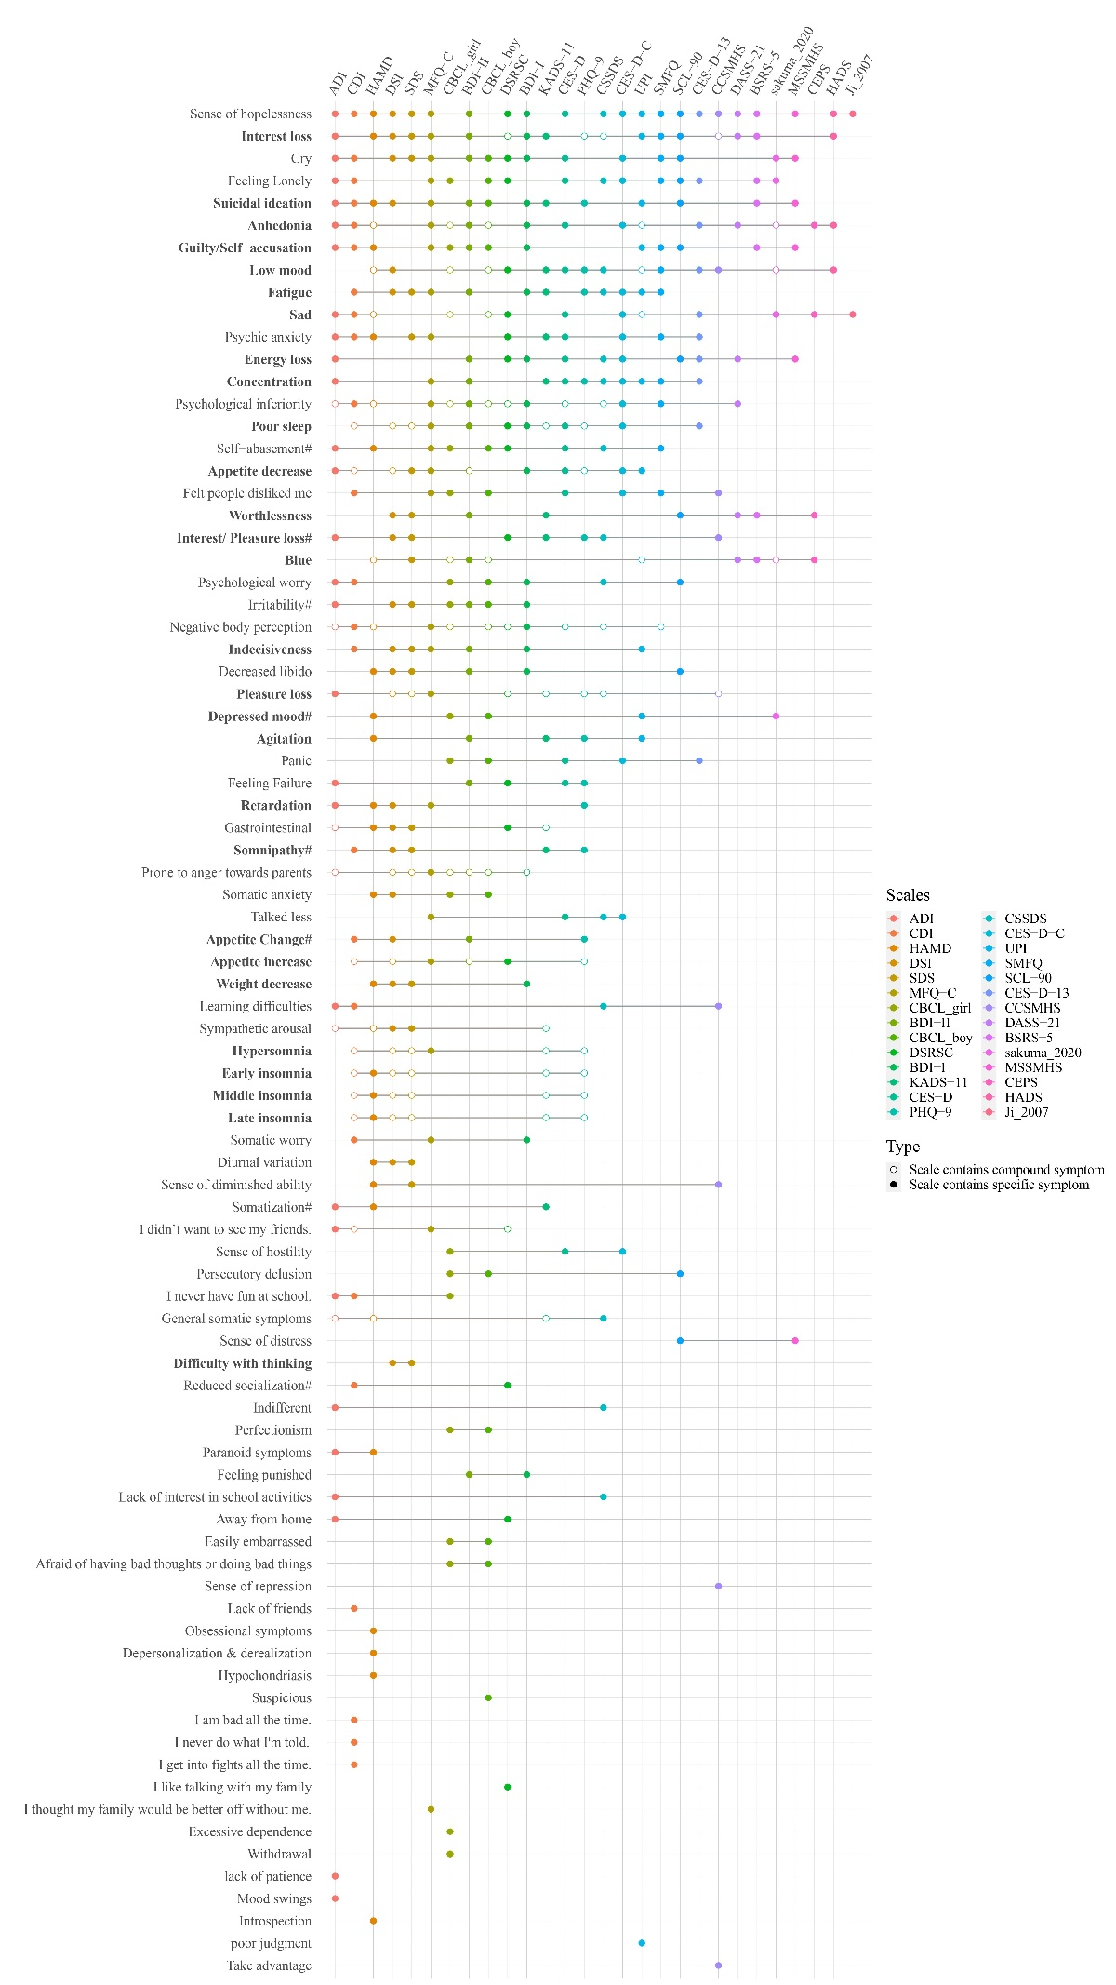

*Depressed mood* is not the most commonly measured symptom across scales because, as mentioned earlier, we retained several symptom descriptions related to depressive mood, including a compound symptom of *depressed mood*, and specific symptoms of *blue*, *low mood*, *sad*,and *anhedonia*. The compound symptom *Depressed mood* was measured by 5 scales, the specific symptom *blue* was measured by 10 scales, *low mood* by 15 scales, *sad* by 13 scales, *anhedonia by 16 scales.* If these symptoms were combined with *depressed mood*, this symptom would be the most frequent symptom among the 25 scales. Table 4 lists in how many scales each of the symptoms are listed; for instance, 11 of the 84 symptoms (13.10%) appear across a subset of 2 scales. Among the 84 symptoms, 18 (21.43%) were idiosyncratic symptoms and only appeared in one scale. None of the symptoms were present on all scales.

Table 4 Number of symptoms that appear across combinations of scales.

|  |  |  |
| --- | --- | --- |
| Symptoms | Scales | % |
| 18 | 1 | 21.43 |
| 11 | 2 | 13.10 |
| 7 | 3 | 8.33 |
| 7 | 4 | 8.33 |
| 7 | 5 | 8.33 |
| 7 | 6 | 8.33 |
| 3 | 7 | 3.57 |
| 4 | 8 | 4.76 |
| 2 | 9 | 2.38 |
| 1 | 10 | 1.19 |
| 5 | 11 | 5.95 |
| 2 | 12 | 2.38 |
| 2 | 13 | 2.38 |
| 3 | 14 | 3.57 |
| 2 | 15 | 2.38 |
| 1 | 16 | 1.19 |
| 1 | 18 | 1.19 |
| 1 | 22 | 1.19 |

*Note.* There are 18 symptoms that appear only in one scale; these symptoms are referred to as idiosyncratic symptoms.

Table 5 provides a comprehensive overview of the symptom count encompassed by each scale, the adjusted scale length, the number of idiosyncratic symptoms and the ratios of compound and specific symptoms. Furthermore, it outlines the prevalence of DSM-5 depressive symptoms within each scale. Among the scales analyzed, 19 did not include any idiosyncratic symptoms. The CSSMHS exhibited the highest percentage of idiosyncratic symptoms, with a prevalence of 22.22%, while the remaining scales showed varying rates of idiosyncratic symptom inclusion, ranging from 3.85% to 12.5%. Ten scales did not incorporate compound symptoms, with proportions for the remaining scales varying from 7.69% to 47.37%. The DSI exhibited the highest prevalence of DSM-5 depression symptoms, encompassing 71.42% of the total nine DSM-5 depression symptoms. Conversely, the Ji_2005 scale demonstrated the lowest representation, comprising only 3.57% of the nine DSM-5 depression symptoms. It is also the least number of items among the scales included in this study.

Table5 Characteristics of the scales

|  |  |  |  |  |  |  |
| --- | --- | --- | --- | --- | --- | --- |
| Scale | Symptoms  captured  (No.) | Adjusted  scale  length  (No.) | Idiosyncratic  symptoms (%) | Specific  symptoms (%) | Compound  symptoms (%) | Scale captures X% of 9 DSM-5 MDD symptoms |
| SDS | 26 | 19 | 0 | 73.08 | 26.92 | 57.14 |
| SCL-90 | 12 | 12 | 0 | 100 | 0 | 17.86 |
| CES-D | 19 | 17 | 0 | 89.47 | 10.53 | 25 |
| CDI | 32 | 24 | 12.5 | 75 | 25 | 53.57 |
| DSRSC | 21 | 16 | 4.76 | 76.19 | 23.81 | 28.57 |
| BDI-I | 20 | 19 | 0 | 95 | 5 | 35.71 |
| MSSMHS | 6 | 6 | 0 | 100 | 0 | 10.71 |
| BDI-II | 23 | 20 | 0 | 86.96 | 13.04 | 53.57 |
| PHQ-9 | 19 | 10 | 0 | 52.63 | 47.37 | 64.29 |
| DASS-21 | 7 | 7 | 0 | 100 | 0 | 17.85 |
| CBCL_boy | 23 | 16 | 4.35 | 69.57 | 30.43 | 25 |
| CBCL_girl | 24 | 17 | 8.33 | 70.83 | 29.17 | 21.43 |
| MFQ-C | 26 | 26 | 3.85 | 100 | 0 | 46.43 |
| CSSDS | 18 | 14 | 0 | 77.78 | 22.22 | 25 |
| CES-D-C | 16 | 16 | 0 | 100 | 0 | 25 |
| ADI | 35 | 29 | 5.71 | 82.86 | 17.14 | 39.29 |
| BSRS-5 | 7 | 7 | 0 | 100 | 0 | 17.86 |
| CES-D-13 | 10 | 10 | 0 | 100 | 0 | 21.43 |
| CEPS | 4 | 4 | 0 | 100 | 0 | 14.29 |
| DSI | 29 | 20 | 0 | 68.97 | 31.03 | 71.42 |
| HADS | 4 | 4 | 0 | 100 | 0 | 10.71 |
| HAMD | 32 | 24 | 12.5 | 75 | 25 | 50 |
| Ji_2007 | 2 | 2 | 0 | 100 | 0 | 3.57 |
| KADS-11 | 20 | 11 | 0 | 55 | 45 | 53.57 |
| Sakuma_2010 | 7 | 4 | 0 | 57.14 | 42.86 | 17.86 |
| SMFQ | 13 | 12 | 0 | 92.31 | 7.69 | 17.86 |
| UPI | 15 | 11 | 6.67 | 73.33 | 26.67 | 46.43 |
| CSSMHS | 10 | 8 | 20 | 80 | 20 | 14.29 |

*Note.* Due to the coding method used in this study (refer to section 3.1.3), the scales might capture more symptoms than the number of items, meaning the values in the first column could be higher than those in the second column.

# 3.4 Scale overlap

The degree of overlap between scales was calculated using the Jaccard coefficient. The average overlap across all scales was 0.19, indicating a very low level of similarity between these scales. For the specific degree of overlap between each pair of scales and the average overlap with other scales, refer to Figure 2.

None of the scales exhibited a mean overlap within the moderate range (0.40 - 0.59) with other scales. CES-D with other scale has the highest average degree of overlap, at 0.25, other scale of average degree of overlap between 0.09 to 0.25. The two scales with the highest overlap were CES-D and CES-D-C at 0.75, followed by DSI and SDS at 0.72.

There are a lot of scales that have zero overlap with each other, that is, they have nothing to do with each other. MSSMHS and CEPS exhibit no overlap; there is no overlap between PHQ-9 and both CEPS and Ji_2005; CSSDS and CEPS lack overlap; CEPS, SMFQ, and CSSMHS do not overlap; Ji_2005 and KADS-11 show no overlap.

The correlation coefficient between the mean Jaccard coefficient of each scale and the length of the scale is 0.55, while the correlation coefficient with the number of captured symptoms is 0.71 (Table 4, columns 1 and 2). This suggests that longer scales exhibit increased overlap with other scales, thus demonstrating enhanced representativeness.

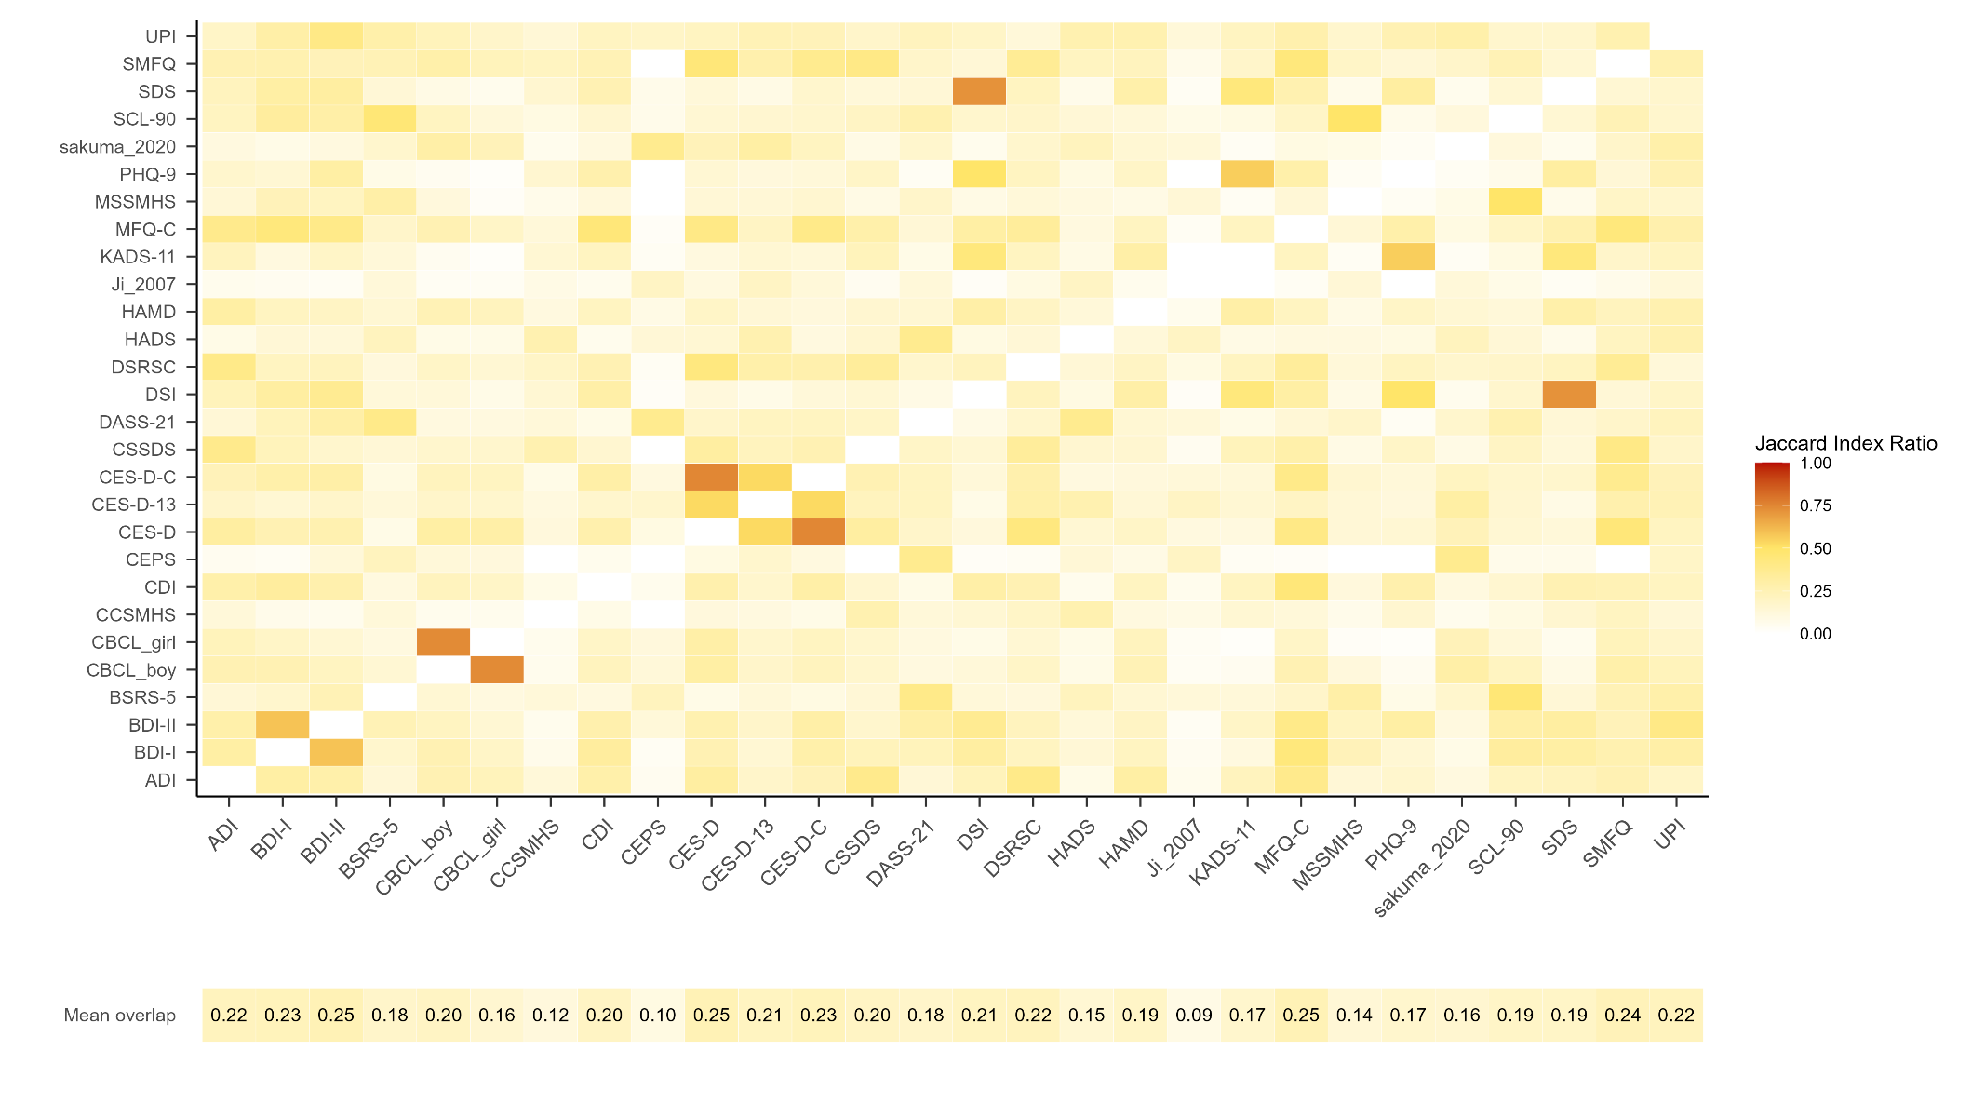

# 4 讨论

[第一段的主旨句]

研究分析了多个常用的抑郁量表，并发现它们在捕捉抑郁症状方面存在较大的异质性。这些量表之间的项目内容重叠度较低。这对于使用和解释相关数据有重要的启示作用。

[第二段的主旨句]

Fried (2017).的研究中Ces-d与其他量表有着最差的平均重叠率（0.27），而Ces-d在本研究中表现出最高的平均重叠率（0.25），可能是由于：1、本研究中除Ces-d以外还纳入了Ces-d简版以及Ces-d儿童版。2、在他的研究中Ces-d有33%的独特症状，而本研究中，随着纳入的量表增加，Ces-d的独特症状为0。

[第三段的主旨句]

抑郁量表的异质性来源可能是由于构念的不清晰，因此，在合并来自不同量表的研究结果时（例如元分析），特别是那些几乎没有重叠的量表时，可能不明智。

[第四段的主旨句]

不能认为低重叠就是糟糕的量表，高重叠就是好的量表。选择测量工具时应考虑多种因素，并根据评估的目的和目标进行选择。

[第五段的主旨句]

目前仍普遍认为量表可以互相替代，研究结果表明量表之间异质性非常强。因此在推广结果中应该强调这是某个量表的结果。

[第六段的主旨句]

确定哪些量表是合适的量表非常重要，我们团队正在使用cosmin系统对本次研究中涉及的量表进行评估。

**参 考 文 献**

于晓琪, 张亚利, 俞国良. (2022). 2010～2020中国内地高中生心理健康问题检出率的元分析. *心理科学进展*, *30*(05), 978-990.

黄潇潇, 张亚利, 俞国良. (2022). 2010～2020中国内地小学生心理健康问题检出率的元分析. *心理科学进展*, *30*(05), 953-964.

张亚利, 靳娟娟, 俞国良. (2022). 2010～2020中国内地初中生心理健康问题检出率的元分析. *心理科学进展*, *30*(05), 965-977.

陈雨濛, 张亚利, 俞国良. (2022). 2010～2020中国内地大学生心理健康问题检出率的元分析. *心理科学进展*, *30*(05), 991-1004.

汪向东等. (1999). *心理卫生评定量表手册*. 中国心理卫生杂志社.

章婕, 吴振云, 方格, 李娟, 韩布新, 陈祉妍. (2010). 流调中心抑郁量表全国城市常模的建立. *中国心理卫生杂志*, *24*(02), 139-143.

Gu, J., & Chen, S. (2020). Association between active travel to school and depressive symptoms among early adolescents. *Children*, *7*(5), 41.

季成叶. (2007). *中国青少年健康相关/危险行为调查综合报告-2005*. 北京大学医学出版社.

张明园. (1998). *精神科评定量表手册*. 湖南科学技术出版社.

陈姜, 张德甫, 吴敏, 胡巧云, 徐俊娥, 付喜成. (2000). 中学生焦虑情绪调查. *中国校医*(04), 257-258.

Jordan, K. M., Ayers, P. M., Jahn, S. C., Taylor, K. K., Huang, C., Richman, J., & Jason, L. A. (2000). Prevalence of fatigue and chronic fatigue syndrome-like illness in children and adolescents. *Journal of Chronic Fatigue Syndrome*, *6*(1), 3-21.

王汝展, 刘兰芬, 葛红敏, 韩建波. (2009). ZUNG氏抑郁自评量表(SDS)作为外科住院患者抑郁障碍常规筛查工具的可行性研究. *精神医学杂志*, *22*(04), 251-253.

Zung, W. W. (1965). A self-rating depression scale. *Archives of General Psychiatry*, *12*(1), 63-70.

任艳峰, 翟强, 王素珍. (2015). 初中生睡眠质量与肥胖的相关性分析. *中国学校卫生*, *36*(09), 1316-1318.

苏春燕, 张洪君, 王宜芝. (2003). 癌症末期病人家属感受和需求的调查. *护理研究*(09), 519-520.

张作记. (2005). *行为医学量表手册*. 行为医学量表手册.

姚树桥, 孙学礼. (2008). *医学心理学.第5版*. 医学心理学.第5版.

戴晓阳. (2010). *常用心理评估量表手册*. 人民军医出版社.

王俊, 金岳龙, 陈燕, 余结根, 贺连平, 姚应水. (2013). 医学院校大学生抑郁情绪与生活事件的相关分析. *皖南医学院学报*, *32*(02), 151-153.

崔庆霞, 王在翔. (2014). 大学生抑郁现状调查及影响因素研究. *中国卫生事业管理*, *31*(08), 629-630.

段泉泉, 胜利. (2012). 焦虑及抑郁自评量表的临床效度. *中国心理卫生杂志*, *26*(09), 676-679.

郑世华, 仝巧云, 郑爱军. (2016). 大学生抑郁和焦虑状况调查及相关因素分析. *重庆医学*, *45*(20), 2835-2837.

王征宇, 迟玉芬. (1984). 抑郁自评量表(SDS). *上海精神医学*(02), 71-72.

张明园等. (2015). *精神科评定量表手册*. 湖南科学技术出版社.

Zung, W. W. (1969). A cross-cultural survey of symptoms in depression. *American Journal of Psychiatry*, *126*(1), 116-121.

崔杰诚, 陈国生. (1998). 《心理卫生与精神科评定量表》专辑. *健康心理学杂志*, *６*(10), 140-141.

戴海崎, 张锋, 陈雪枫. (2007). *心理与教育测量: 修订版*. 广州: 暨南大学出版社.

仲稳山. (2009). *心理诊断学*. 苏州: 苏州大学出版社.

王征宇. (1984). 症状自评量表(SCL-90). *上海精神医学*(02), 68-70.

高成阁, 王友平, 亢万虎, 张西生, 李强, 方明,... 何瑞嫦. (1997). 陕西省大中学生心理健康水平调查. *中国临床心理学杂志*(01), 42-43.

Derogatis, L. R., Rickels, K., & Rock, A. F. (1976). The SCL-90 and the MMPI: A step in the validation of a new self-report scale. *The British Journal of Psychiatry*, *128*(3), 280-289.

陈树林, 李凌江. (2003). SCL-90信度效度检验和常模的再比较. *中国神经精神疾病杂志*(05), 323-327.

黄赐英, 裴利华. (2005). 大学新生SCL—90调查结果与分析. *株洲师范高等专科学校学报*(03), 29-32.

陈国鹏. (2005). *心理测验与常用量表*. 上海: 上海科学普及出版社.

Mensah, F. K., & Kiernan, K. E. (2010). Parents’ mental health and children’s cognitive and social development: families in England in the Millennium Cohort Study. *Social Psychiatry and Psychiatric Epidemiology*, *45*, 1023-1035.

金华, 吴文源, 张明园. (1986). 中国正常人SCL-90评定结果的初步分析. *中国神经精神疾病杂志*(05), 260-263.

Derogatis, L. R. (1973). SCL-90: an outpatient psychiatric rating scale-preliminary report. *Psychopharmacol Bull*, *9*, 13-28.

Derogatis, L. R. (1977). *The SCL‐90: Administration, Scoring and Procedures Manual*. Baltimore, MD, USA: John Hopkins University Press.

Hoffmann, N. G., & Overall, P. B. (1978). Factor structure of the SCL-90 in a psychiatric population. *Journal of Consulting and Clinical Psychology*, *46*(6), 1187.

史从戎, 张曼华, 王宇, 来源, 高保兴, 乔晓春. (2011). 我国部分农村地区受艾滋病影响儿童心理弹性的保护性因素研究. *中国儿童保健杂志*, *19*(01), 10-12.

Radloff, L. S. (1991). The use of the Center for Epidemiologic Studies Depression Scale in adolescents and young adults. *Journal of Youth and Adolescence*, *20*(2), 149-166.

Cheng, C., Yen, C., Ko, C., & Yen, J. (2012). Factor structure of the center for epidemiologic studies depression scale in Taiwanese adolescents. *Comprehensive Psychiatry*, *53*(3), 299-307.

Lee, S. W., Stewart, S. M., Byrne, B. M., Wong, J. P., Ho, S. Y., Lee, P. W., & Lam, T. H. (2008). Factor structure of the Center for Epidemiological Studies Depression scale in Hong Kong adolescents. *Journal of Personality Assessment*, *90*(2), 175-184.

Cheung, C., & Bagley, C. (1998). Validating an American scale in Hong Kong: the center for epidemiological studies depression scale (CES-D). *The Journal of Psychology*, *132*(2), 169-186.

陈祉妍, 杨小冬, 李新影. (2009). 流调中心抑郁量表在我国青少年中的试用. *中国临床心理学杂志*, *17*(04), 443-445.

Wang, M., Armour, C., Wu, Y., Ren, F., Zhu, X., & Yao, S. (2013). Factor structure of the CES‐D and measurement invariance across gender in mainland Chinese adolescents. *Journal of Clinical Psychology*, *69*(9), 966-979.

Yang, L., Jia, C., & Qin, P. (2015). Reliability and validity of the Center for Epidemiologic Studies Depression Scale (CES-D) among suicide attempters and comparison residents in rural China. *BMC Psychiatry*, *15*(1), 1-8.

Radloff, L. S. (1977). The CES-D scale: A self-report depression scale for research in the general population. *Applied Psychological Measurement*, *1*(3), 385-401.

潘丝媛, 李武权, 黎明, 郭蓝, 邓雪清, 卢次勇. (2018). 广州市中学生网络成瘾与自杀相关行为的关系. *中国学校卫生*, *39*(02), 229-231.

Jiang, L., Wang, Y., Zhang, Y., Li, R., Wu, H., Li, C., ... Tao, Q. (2019). The reliability and validity of the center for epidemiologic studies depression scale (CES-D) for Chinese university students. *Frontiers in Psychiatry*, *10*, 315.

刘平. (1999). 流调中心用抑郁量表（Center for Epidemiological Studies Depression Scale，CES-D）. *中国心理卫生杂志（增刊）*, 200-202.

刘琰, 谭曦, 李扬, 徐芳, 张杰, 孔军辉. (2015). 大学生抑郁情绪现状及影响因素分析. *中华全科医学*, *13*(01), 91-93.

Kovacs, M. (1992). Children’s depression inventory. *Acta Paedopsychiatrica: International Journal of Child & Adolescent Psychiatry*.

Beck, A. T., Ward, C. H., Mendelson, M., Mock, J., & Erbaugh, J. (1961). An inventory for measuring depression. *Archives of General Psychiatry*, *4*(6), 561-571.

洪忻, 李解权, 梁亚琼, 王志勇, 徐斐. (2012). 儿童抑郁量表中文版在中学生中的信效度分析. *中国学校卫生*, *33*(10), 1182-1185.

陈海燕, 姚树桥, 明庆森, 侯婵娟. (2012). 中学生的抑郁症状与生活事件:非适应性策略的中介作用. *中国心理卫生杂志*, *26*(10), 786-790.

俞大维, 李旭. (2000). 儿童抑郁量表(CDI)在中国儿童中的初步运用. *中国心理卫生杂志*(04), 225-227.

吴文峰, 卢永彪, 谭芙蓉, 姚树桥. (2010). 儿童抑郁量表中文版在中小学生中的信效度. *中国心理卫生杂志*, *24*(10), 775-779.

Samm, A., Värnik, A., Tooding, L., Sisask, M., Kolves, K., & Von Knorring, A. (2008). Children’s depression inventory in Estonia: single items and factor structure by age and gender. *European Child & Adolescent Psychiatry*, *17*, 162-170.

Kovas, M. (1985). The Children's Depression Inventory (CDI). *Psychological Bulletin*, *21*, 995-998.

苏林雁, 王凯, 朱焱, 罗学荣, 杨志伟, 儿童抑郁量表全国协作组. (2003). 儿童抑郁障碍自评量表的中国城市常模. *中国心理卫生杂志*(08), 547-549.

王凯, 苏林雁, 朱焱, 翟静, 杨志伟, 张纪水. (2002). 儿童焦虑性情绪障碍筛查表的中国城市常模. *中国临床心理学杂志*(04), 270-272.

周德新. (2006). 大学生自杀现象的社会学解读. *湖南文理学院学报(社会科学版)*(05), 60-62.

Beck, A. T., & Beck, R. W. (1972). Screening depressed patients in family practice. A rapid technic. *Postgrad Med*, *52*(6), 81-85. doi: 10.1080/00325481.1972.11713319

Beck, A. T., Steer, R. A., & Carbin, M. G. (1988). Psychometric properties of the Beck Depression Inventory: Twenty-five years of evaluation. *Clinical Psychology Review*, *8*(1), 77-100.

Beck, A. T., & Beamesderfer, A. (1974). *Assessment of depression: the depression inventory.*: S. Karger.

王极盛, 李焰, 赫尔实. (1997). 中国中学生心理健康量表的编制及其标准化. *社会心理科学*(04), 17-22.

王极盛. (1998). *心灵时代*. 中国城市出版社.

杨文辉, 刘绍亮, 周烃, 彭芳, 刘细梅, 李莉,... 蚁金瑶. (2014). 贝克抑郁量表第2版中文版在青少年中的信效度. *中国临床心理学杂志*, *22*(02), 240-245.

王振, 苑成梅, 黄佳, 李则挚, 陈珏, 张海音,... 肖泽萍. (2011). 贝克抑郁量表第2版中文版在抑郁症患者中的信效度. *中国心理卫生杂志*, *25*(06), 476-480.

Wang, D., Ou, C., Chen, M., & Duan, N. (2009). Health-promoting lifestyles of university students in Mainland China. *BMC Public Health*, *9*(1), 1-9.

Dere, J., Watters, C. A., Yu, S. C., Bagby, R. M., Ryder, A. G., & Harkness, K. L. (2015). Cross-cultural examination of measurement invariance of the Beck Depression Inventory–II. *Psychological Assessment*, *27*(1), 68.

Spitzer, R. L., Kroenke, K., Williams, J. B., Patient, H. Q. P. C., & Patient, H. Q. P. C. (1999). Validation and utility of a self-report version of PRIME-MD: the PHQ primary care study. *Jama*, *282*(18), 1737-1744.

Kroenke, K., & Spitzer, R. L. (2002). The PHQ-9: a new depression diagnostic and severity measure. *Psychiatric Annals*, *32*(9), 509-515.

Sun, X. Y., Li, Y. X., Yu, C. Q., & Li, L. M. (2017). Reliability and validity of depression scales of Chinese version: a systematic review. *Zhonghua Liu Xing Bing Xue Za Zhi= Zhonghua Liuxingbingxue Zazhi*, *38*(1), 110-116.

苑新群. (2014). *大学生媒体多任务与心理健康的关系*. 首都师范大学.

Lovibond, P. F., & Lovibond, S. H. (1995). The structure of negative emotional states: Comparison of the Depression Anxiety Stress Scales (DASS) with the Beck Depression and Anxiety Inventories. *Behaviour Research and Therapy*, *33*(3), 335-343.

龚栩, 谢熹瑶, 徐蕊, 罗跃嘉. (2010). 抑郁-焦虑-压力量表简体中文版(DASS-21)在中国大学生中的测试报告. *中国临床心理学杂志*, *18*(04), 443-446.

苏林雁, 李雪荣, 罗学荣, 万国斌, 杨志伟. (1998). Achenbach儿童行为量表的再标准化及效度检验. *中国心理卫生杂志*(02), 4-6.

忻仁娥. (1994). Achenbach 儿童行为量表( 中国标准化). *上海精神医学*, *4*(1), 1-2.

Achenbach, T., & Edelbrock, C. (1987). *Manual for the Child Behavior Checklist*. Burlington: University of Vermont.

Wood, A., Kroll, L., Moore, A., & Harrington, R. (1995). Properties of the mood and feelings questionnaire in adolescent psychiatric outpatients: a research note. *Journal of Child Psychology and Psychiatry*, *36*(2), 327-334.

曹枫林, 苏林雁, 程培霞. (2009). 情绪问卷中文版用于中学生的信度和效度研究. *中国临床心理学杂志*, *17*(04), 440-442.

王极盛, 邱炳武, 赫尔实. (1997). 中学生抑郁量表的编制及其标准化. *社会心理科学*(3), 3.

William Li, H. C., Chung, O. K. J., & Ho, K. Y. (2010). Center for epidemiologic studies depression scale for children: psychometric testing of the Chinese version. *Journal of Advanced Nursing*, *66*(11), 2582-2591.

Huang, C. Y., & Hsu, W. Y. (2003). A study of developing an adolescent depression inventory. *Journal of Education Psychology*, *26*, 167-190.

楊雅惠. (2003). 依附,負向情緒調適預期和壓力因應對情緒經驗的影響歷程之探討:以大四學生的生涯抉擇壓力為例.

Lee, M., Lee, Y., Yen, L., Lin, M., & Lue, B. (1990). Reliability and validity of using a brief psychiatric symptom rating scale in clinical practice. *Journal of the Formosan Medical Association*, *89*(12), 1081-1087.

Li, L. W., Liu, J., Xu, H., & Zhang, Z. (2016). Understanding rural–urban differences in depressive symptoms among older adults in China. *Journal of Aging and Health*, *28*(2), 341-362.

张宝山, 李娟. (2011). 简版流调中心抑郁量表在全国成年人群中的信效度. *中国心理卫生杂志*, *25*(07), 506-511.

Ma, L., Gao, L., Chiu, D. T., Ding, Y., Wang, W., & Wang, Y. (2020). Depressive symptoms prevalence, associated family factors, and gender differences: a national cohort study of middle school students in China. *Journal of Affective Disorders*, *274*, 545-552.

Zigmond, A. S., & Snaith, R. P. (1983). The Hospital Anxiety and Depression Scale. *Acta Psychiatrica Scandinavica*, *67*(6), 361-370.

汤毓华, 张明园. (1984). 汉密顿抑郁量表(HAMD). *上海精神医学*(02), 61-64.

周慧鸣, 郝楠, 杜亚松, 刘艳玉, 隋雨彤, 王艳华,... KUTCHER Stanley. (2015). 中文版Kutcher青少年抑郁量表测评青少年样本的效度与信度. *中国心理卫生杂志*, *29*(06), 413-418.

Sakuma, K. K., Sun, P., Unger, J. B., & Johnson, C. A. (2010). Evaluating depressive symptom interactions on adolescent smoking prevention program mediators: A mediated moderation analysis. *Nicotine & Tobacco Research*, *12*(11), 1099-1107.

程培霞, 曹枫林, 苏林雁. (2009). 简化情绪量表中文版用于中学生的信度和效度. *中国心理卫生杂志*, *23*(01), 60-62.

Yu, L., & Cai, L. (2007). Review on the application of the University Personality Inventory in China and abroad. *Prof Circle*(53), 158-159.

Huang, Q., Li, Y., Huang, S., Qi, J., Shao, T., Chen, X., ... Cai, Y. (2020). Smartphone use and sleep quality in chinese college students: a preliminary study. Front Psychiatry 11: 1–7.

张华. (2021). *散打运动对大学生心理健康影响的教学实验研究*. 河北师范大学.

刘豫鑫, 刘津, 王玉凤. (2010). 简明儿童少年国际神经精神访谈(父母版)的信效度. *中国心理卫生杂志*, *24*(12), 921-925.

刘豫鑫, 刘津, 王玉凤. (2011). 简明儿童少年国际神经精神访谈儿童版的信效度. *中国心理卫生杂志*, *25*(01), 8-13.

Andresen, E. M., Malmgren, J. A., Carter, W. B., & Patrick, D. L. (1994). Screening for depression in well older adults: Evaluation of a short form of the CES-D. *American Journal of Preventive Medicine*, *10*(2), 77-84.

Kessler, R. C., & Stün, T. B. (2004). The World Mental Health (WMH) Survey Initiative version of the World Health Organization (WHO) CompoundInternational Diagnostic Interview (CIDI). *International Journal of Methods in Psychiatric Research*, *13*(2).

宋维真, 张建平. (1993). *心理健康测查表(PHI)使用指导书*

. 北京：中国科学院心理研究所.

Fried, E. I. (2017). The 52 symptoms of major depression: Lack of content overlap among seven common depression scales. *Journal of Affective Disorders*, *208*, 191-197.